|  |
| --- |
|  |
| Social Innovation as Valuation and Outcome Category of SNSF Funded Research |
| Report |

Zentrum für Soziale Innovation

May 2022

**Social Innovation as Valuation and Outcome Category of SNSF funded Research**

ZSI – Zentrum für Soziale Innovation

Suggested citation: Schuch, K., Lampert, D., Neuhuber, T. Koller, K., Demir, U. and L-A. Plumhans (2022). Social Innovation as Valuation and Outcome Category of SNSF funded Research. ZSI: Vienna.

Contact:

Klaus Schuch (schuch@zsi.at)

Linke Wienzeile 246

1150 Vienna

Austria

More information on the ZSI is available on the internet (www.zsi.at).

Vienna: Centre for Social Innovation, May 2022

Table of Content

1) EXECUTIVE SUMMARY 5

2) INTRODUCTION 5

2.1 Rational and background of this study 5

2.2 Study design and applied methods 5

3) SOCIAL INNOVATION AS A RESEARCH CATEGORY 6

3.1 Meaning of Social Innovation 6

3.2 Attributes of Social Innovation 6

4) SOCIAL INNOVATION IN SNSF PROJECTS 7

4.1 Familiarity and self-assessment – a first approximation 7

4.2 Motivation and agency 7

4.3 Extent of trans- and interdisciplinarity in SNSF funded projects 7

4.4 Productive interactions: Obstacles and attempted solutions 8

5) NEW SOCIAL PRACTICES? iNTENDED OUTCOMES, ACTUAL OUTCOMES AND LIMITATIONS 9

5.1 Social innovation outcome orientation in SNSF projects 9

5.2 Actual outcomes and limitations 9

6) the last miles – what does it take? 9

7) WRAP-UP 1: VALUATION of social innovation as potential outcome category of research 9

8) WRAP-UP 2: TOWARDS A MODEL OF ASSESSING snsf’ CONTRIBUTION TO SOCIAL INNOVATIONS 9

9) LITERATURE 9

10) ANNEX 13

**List of Tables**

Table 1**: Analytical dimensions to identify social innovations** 6

**List of Figures**

Figure 1: **Overview on the Research Design** 5

Figure 3: **Multi-method approach** 6

Figure 2**: R&D phases and procedures for social innovation research** 7

1. EXECUTIVE SUMMARY

Our proposal aims to trace contributions of research funded by SNSF to social innovations, and to systematise these contributions in a valuation framework. In addition, we aim to identify to what extent contributions to social innovation in SNSF-funded research projects are possible at all, and where further support measures, either provided by SNSF or from outside (e.g. by the universities), could create an added value that could not be tapped so far.

1. INTRODUCTION

2.1 Rational and background of this study

Our proposal aims to trace contributions of research funded by SNSF to social innovations, and to systematise these contributions in a valuation framework. In addition, we aim to identify to what extent contributions to social innovation in SNSF-funded research projects are possible at all, and where further support measures, either provided by SNSF or from outside (e.g. by the universities), could create an added value that could not be tapped so far.

2.2 Study design and applied methods

Our proposal aims to trace contributions of research funded by SNSF to social innovations, and to systematise these contributions in a valuation framework. In addition, we aim to identify to what extent contributions to social innovation in SNSF-funded research projects are possible at all, and where further support measures, either provided by SNSF or from outside (e.g. by the universities), could create an added value that could not be tapped so far.

Figure 1: **Overview on the Research Design**

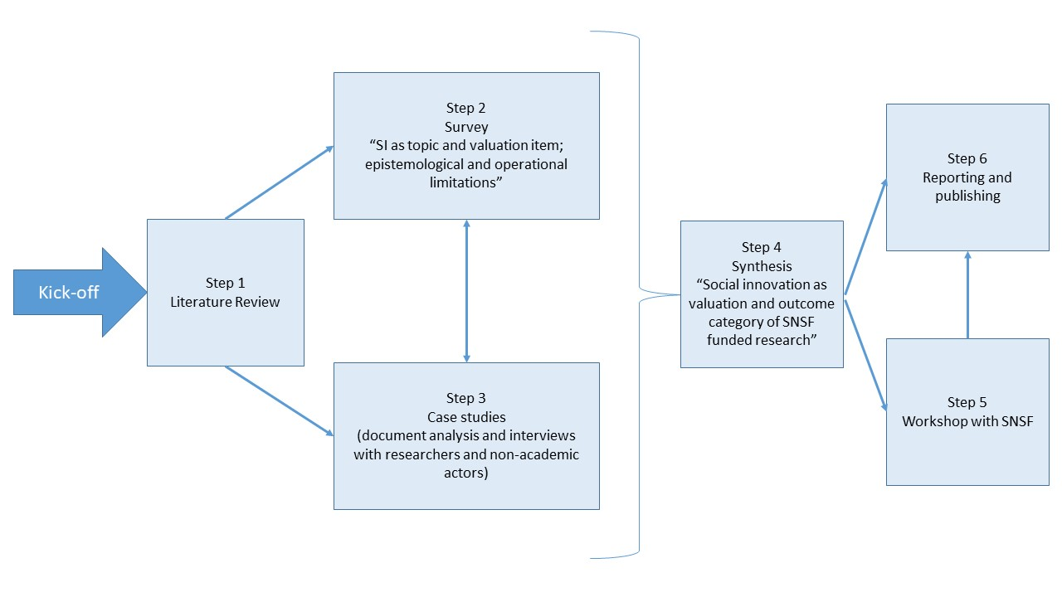

Source: Own illustration

Our proposal aims to trace contributions of research funded by SNSF to social innovations, and to systematise these contributions in a valuation framework. In addition, we aim to identify to what extent contributions to social innovation in SNSF-funded research projects are possible at all, and where further support measures, either provided by SNSF or from outside (e.g. by the universities), could create an added value that could not be tapped so far.

Figure 3: **Multi-method approach**

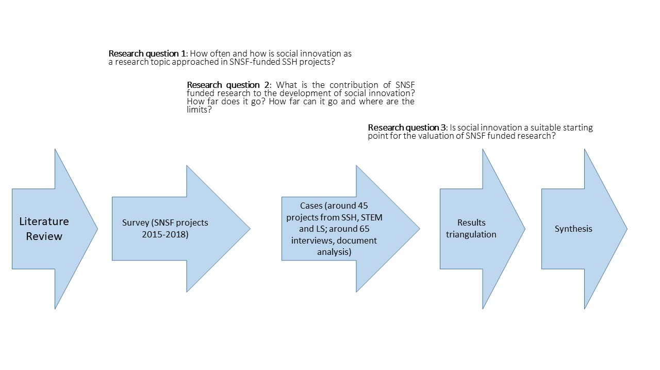

Source: own illustration

1. SOCIAL INNOVATION AS A RESEARCH CATEGORY

3.1 Meaning of Social Innovation

Our proposal aims to trace contributions of research funded by SNSF to social innovations, and to systematise these contributions in a valuation framework. In addition, we aim to identify to what extent contributions to social innovation in SNSF-funded research projects are possible at all, and where further support measures, either provided by SNSF or from outside (e.g. by the universities), could create an added value that could not be tapped so far.

3.2 Attributes of Social Innovation

Our proposal aims to trace contributions of research funded by SNSF to social innovations, and to systematise these contributions in a valuation framework. In addition, we aim to identify to what extent contributions to social innovation in SNSF-funded research projects are possible at all, and where further support measures, either provided by SNSF or from outside (e.g. by the universities), could create an added value that could not be tapped so far.

Table 1**: Analytical dimensions to identify social innovations**

|  |  |
| --- | --- |
| Analytical dimensions | 1. Social innovation results in a *changed social practice* (= object of a social innovation). |
| 1. A social innovation must be *new in a specific context or for a specific actor.* |
| 1. A social innovation is *developed to fulfil a social purpose* in that sense that it aims to better cope with needs and problems than is possible by using existing practices |
| 1. Social innovations are *intentionally solution-oriented* *and prompted by actors or a constellation of actors*. They do not just happen and they are not the same as social change, but they can contribute to it. |
| 1. A social innovation is more than an idea and must be *put into practice* (i.e. difference between idea, invention and innovation in analogy with techno-economic innovation) |

Source: XYZ

Our proposal aims to trace contributions of research funded by SNSF to social innovations, and to systematise these contributions in a valuation framework. In addition, we aim to identify to what extent contributions to social innovation in SNSF-funded research projects are possible at all, and where further support measures, either provided by SNSF or from outside (e.g. by the universities), could create an added value that could not be tapped so far.

1. SOCIAL INNOVATION IN SNSF PROJECTS

4.1 Familiarity and self-assessment – a first approximation

Our proposal aims to trace contributions of research funded by SNSF to social innovations, and to systematise these contributions in a valuation framework. In addition, we aim to identify to what extent contributions to social innovation in SNSF-funded research projects are possible at all, and where further support measures, either provided by SNSF or from outside (e.g. by the universities), could create an added value that could not be tapped so far.

Familiarity and self-assessment were also building blocks of the questionnaire, both of the concepts have been directed to the participants in the same question group with the assessment of experience with the transdisciplinary research. These variables will be vital in the hypothesis testing, as they reflect the respondent’s view on their own competencies and achievements, a self-assessment that can then be contrasted with their responses on other potential key factors, such as the project’s non-academic outcomes or the inclusion of non-academic actors in their SNSF funded projects. More information on the testing of the hypotheses can be found in chapter 4; this chapter shows first the results of the descriptive statistics.

The first variable to analyse in this group of question is *experience with* *transdisciplinary research*. There are several ways to approach the concept of transdisciplinarity. In the context of this study, we refer to the Swiss Academy of Sciences who understands[1] *transdisciplinary research* as research linking “[…] *societal problem solving with scientific knowledge production in a process of co-producing knowledge*.”

Scholarly literature goes as far as stating that *transdisciplinary aspects* are central (and necessary) to SI-related research. Thus, it could be argued that *transdisciplinarity* ought to be regarded as a potentially important indicator for SI-relevant outcomes. In contrast to this notion, however, our theoretical framework does not consider *transdisciplinary involvement* a necessary prerequisite for research projects to contribute to SI. That said, we still expect it to be more influential than other factors (for a more detailed exploration, see Section **Error! Reference source not found.**).

When asked about their ***experience with transdisciplinary research***, 48 % of respondents stated that they are indeed experienced (7 and above on a 0-10 scale; 10 being the maximum), 26 % replied to be somewhat experienced, and another 26 % that they were not experienced (3 and below; 0 being the minimum). **Error! Reference source not found.** (first row) provides a visual overview on this distribution, while **Error! Reference source not found.** (left columns) details all the responses in each category separately. The latter also shows that, out of 361 overall survey participants, 352 chose to answer this particular question, while 9 refrained from answering.

Figure 1: SI-familiarity, familiarity with transdisciplinarity, and project’s contribution to SI (self-assessment)

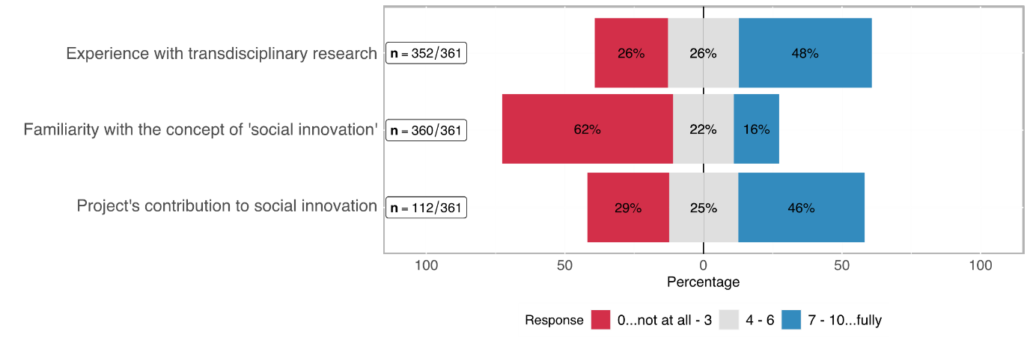

Table 1: Self-assessment in terms of transdisciplinary experience, familiarity with SI, project's contribution to SI

|  |  |  |  |  |  |  |
| --- | --- | --- | --- | --- | --- | --- |
| Rating | Transdisciplinary experience  (n = 352) | | Familiarity with SI  (n = 360) | | Project's contribution to SI  (n = 112) | |
| *0..lowest*  *10..highest* | abs | % | abs | % | abs | % |
| 0 | 19 | 5.26% | 116 | 32.22% | 5 | 4.46% |
| 1 | 17 | 4.71% | 36 | 10.00% | 3 | 2.68% |
| 2 | 26 | 7.20% | 33 | 9.17% | 12 | 10.71% |
| 3 | 31 | 8.59% | 37 | 10.28% | 13 | 11.61% |
| 4 | 21 | 5.82% | 25 | 6.94% | 7 | 6.25% |
| 5 | 37 | 10.25% | 37 | 10.28% | 13 | 11.61% |
| 6 | 32 | 8.86% | 17 | 4.72% | 8 | 7.14% |
| 7 | 58 | 16.07% | 19 | 5.28% | 17 | 15.18% |
| 8 | 40 | 11.08% | 20 | 5.56% | 22 | 19.64% |
| 9 | 27 | 7.48% | 6 | 1.67% | 6 | 5.36% |
| 10 | 44 | 12.19% | 14 | 3.89% | 6 | 5.36% |
| no response | *9* |  | *0* |  | *1* |  |

As regards the ***familiarity with SI***, 360 participants responded. 62 % of whom stated to be *not at all* to *barely* familiar with the idea of SI (3 and below on a 0-10 scale), roughly 22 % consider themselves as moderately familiar (4-6 on that scale), and 16 % as *familiar* to *highly familiar*. Figure 1 (second row) provides a visual overview on this distribution, while Table 1 (centre columns) details all the responses in each category separately.

This variable is particularly interesting when further analysing whether researchers from a scientific domain are more familiar with the concept than researchers from another scientific domain –Section **Error! Reference source not found.** answers this question. Overall, we can summarise that a rudimentary conceptual understanding of SI not (yet) common sense in the scientific world.

Out of the 113 *eligible*[2] participants, i. e. those who believe to be at least moderately familiar with SI, 112 chose to answer the question regarding their ***project’s contribution to SI*** (see bottom row of Figure 1 above). Of those, 29 % stated that their project contributed little to nothing to SI, while 46 % stated that it was high to very high.

4.1.1 Respondents’ experience with transdisciplinary research and age

This sub-section follows up on the question, whether the respondents’ *age* had anything to do with their *experience with transdisciplinary research*. Figure 1 shows the distribution of the transdisciplinary experience on the x-axis (0..10 from lowest to highest), while the age groups are shown on the y-axis. Some variance is noticeable but a general trend is not visible. Even the younger age groups are spread across a low to a high degree of transdisciplinary experience.

Chapter **Error! Reference source not found.** (pp. **Error! Bookmark not defined.**) examines interesting potential correlations but, as a sneak preview, we can already say that this one is not among them, because the two variables “age” and “transdisciplinary experience” do not correlate strongly enough to be considered important factors contributing to SI.

Figure 1: Distribution of the transdisciplinary experience across age groups

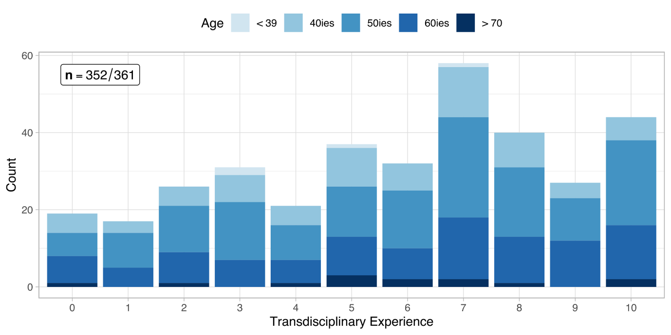

4.1.2. Respondents’ familiarity with social innovation and scientific domains

SI is a relatively little-known concept among most of the survey respondents as described above. The question is, though, whether there is a difference between scientific domains when it comes to the familiarity of researchers with the concept of SI.

The distribution of participants across the three domains is balanced, each represents roughly one third of the overall number of participants (cf. **Error! Reference source not found.**). As Figure 2 and **Error! Reference source not found.** Show, the share of researchers from the Humanities and Social Sciences increases with each higher degree of *familiarity with SI* while the share of the other two domains dwindles in comparison.

This observation corresponds with our expectations and will further be examined in the hypothesis chapter in section **Error! Reference source not found.** (pp. **Error! Bookmark not defined.**) of the chapter on hypotheses.

Figure 2: Distribution of the familiarity with SI

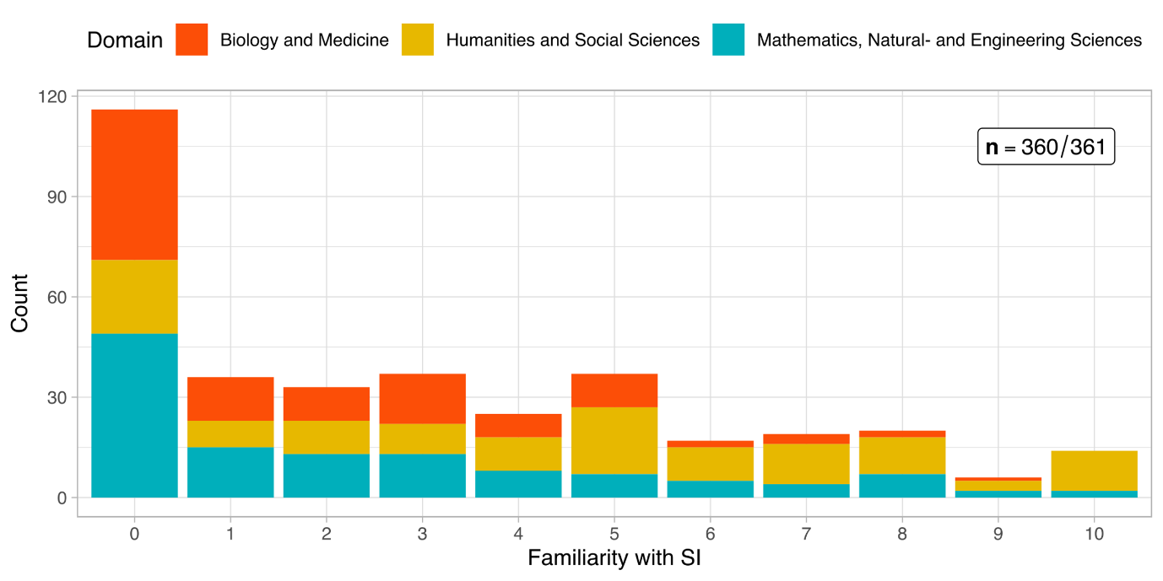

4.1.3. Project’s contribution to SI (self-assessment)

Respondents were asked about their project’s contribution to SI as a control variable, firstly, to scrutinise the relationship between the self-assessment and a model-driven SI-Index[3], and secondly, to conclude if the self-assessment was generally overestimated. As the figure below and **Error! Reference source not found.** show, there is no clear distribution across the offered rating spectrum.

Figure 3: Distribution of self-assessed SI-Contribution

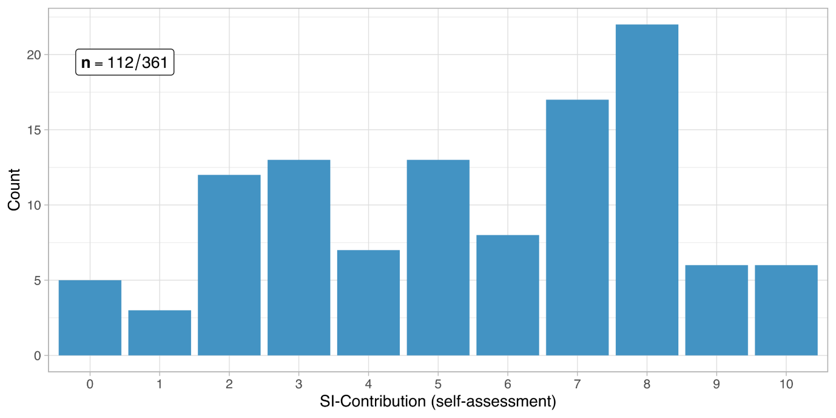

4.2 Motivation and agency

Our proposal aims to trace contributions of research funded by SNSF to social innovations, and to systematise these contributions in a valuation framework. In addition, we aim to identify to what extent contributions to social innovation in SNSF-funded research projects are possible at all, and where further support measures, either provided by SNSF or from outside (e.g. by the universities), could create an added value that could not be tapped so far. Our analysis approached to the research motivation and agency from different directions by identifying types of motivation and intention to benefit the society outside of academia.

Motivation types

The type of motivation that drives academics to conduct research is important to understand the content orientation, the design, and the results of the study. The initial motivation types measured in this study consist of three main categories, namely, motivation to *better understand a natural, technical, economic, or social phenomenon* (basic academic motivation that drives research), to *directly address a natural, technical, economic, or social problem* (use-inspired research)*,* to *improve the human condition/welfare* (motivation to create impact outside of academia).

The basic academic motivation to better understand a natural, technical, economic or social phenomenon was strongly emphasised in the survey results (see Figure 1): 84 % of the survey respondents marked academic motivation greater or equal to 7 on a 0-10 scale, it has also one of the highest response ratios in the survey (only one responded did not reply to this question). This was followed by motivation to directly address a problem (64 % of the respondents noting equal to or higher levels than 7). Improving the human condition/welfare, i. e. the motivation closest associated with social innovation, namely to cause social impact outside of academia, was more balanced in comparison. 35 % of the respondents replied with levels equal to or smaller than 3 and 45 % with levels equal to or higher than 7, in terms of improving the human condition/welfare being one of the main motivations in their research project. For more detailed responses, refer to Table 1.

We can conclude that the motivation portfolio of SNSF-funded principal investigators is, overall, not one-dimensionally oriented towards only the basic scientific motivation of better understanding a phenomenon, but includes also a remarkable share of problem-orientation and use-inspiration including a quite strongly expressed notion of doing good for human condition/welfare. A high proportion of SNSF-funded projects have thus the motivational potential to more directly contribute to SI through their research.

Figure 1: Distribution of different motivation types

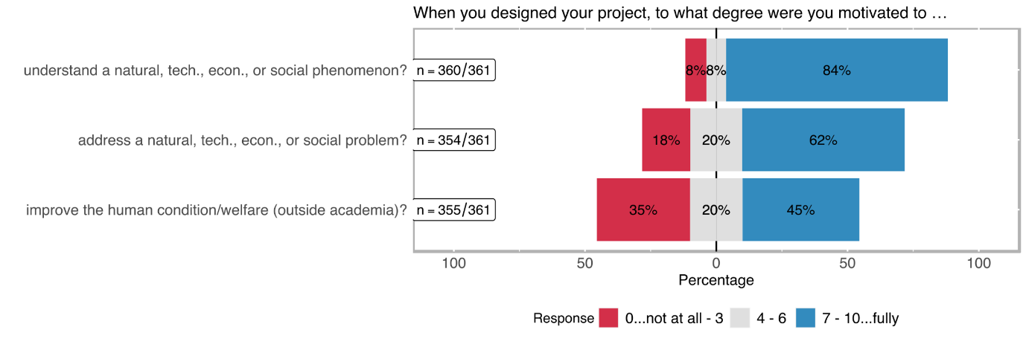

Table 1: Distribution of different motivation types

|  |  |  |  |  |  |  |
| --- | --- | --- | --- | --- | --- | --- |
| rating | better understand a natural, technical, economic, or social phenomenon?  (n=360) | | directly address a natural, technical, economic, or social problem?  (n=354) | | improve the human condition/welfare (outside academia)?  (n=355) | |
| *0..lowest*  *10..highest* | **abs** | **%** | **abs** | **%** | **abs** | **%** |
| 0 | 14 | 3.89% | 23 | 6.50% | 47 | 13.24% |
| 1 | 1 | 0.28% | 7 | 1.98% | 23 | 6.48% |
| 2 | 8 | 2.22% | 25 | 7.06% | 30 | 8.45% |
| 3 | 6 | 1.67% | 10 | 2.82% | 26 | 7.32% |
| 4 | 12 | 3.33% | 16 | 4.52% | 16 | 4.51% |
| 5 | 9 | 2.50% | 28 | 7.91% | 43 | 12.11% |
| 6 | 6 | 1.67% | 26 | 7.34% | 12 | 3.38% |
| 7 | 17 | 4.72% | 36 | 10.17% | 41 | 11.55% |
| 8 | 42 | 11.67% | 56 | 15.82% | 53 | 14.93% |
| 9 | 38 | 10.56% | 28 | 7.91% | 15 | 4.23% |
| 10 | 207 | 57.50% | 99 | 27.97% | 49 | 13.80% |
| *no response* | *1* |  | *7* |  | *6* |  |

Intention to benefit the non-academic world

Approximately 37 % of the respondents note that their projects were not specifically designed to benefit a social group (cf. Figure 2 and Table 2). Almost exactly the same number of respondents indicated that this type of deliberative design was only present to a minor extent in their research project. 25 % of the respondents noted that their projects were specifically designed to generate a benefit for the general population or a specific social group.

Figure 2: Distribution of extent to benefit target groups outside the academic world

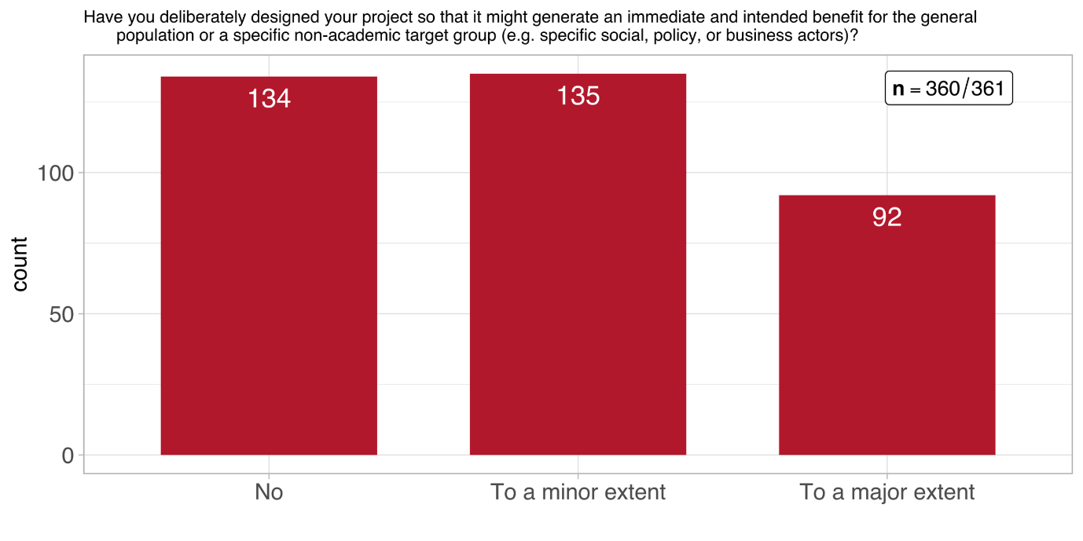

Table 2: Distribution of extent to benefit target groups outside the academic world (n = 360)

|  |  |  |
| --- | --- | --- |
| response | abs | % |
| no | 133 | 36.94% |
| to a minor extent | 135 | 37.50% |
| to a large extent | 92 | 25.56% |
| *no response* | *1* |  |

Figure 3 breaks these numbers down by scientific domain. It shows clearly that *Mathematics, Natural- and Engineering Sciences* has the highest number of projects which do not intent to benefit any target groups outside academia. That said, their number if matched by projects in this domain what intent to achieve such a benefit to either a minor or large extent. Out of the three scientific domains, *Humanities and Social Sciences* can – unsurprisingly – claim the highest number of projects which intend to contribute to a large extent to target groups outside academia.

Figure 3: Distribution of extent to benefit target groups outside the academic world across scientific domains

Table 3 shows these values broken down by *funding instrument*. Apparently, none of the them sticks out in terms a considerably higher share of a response category, compared to the overall distribution across categories. The exception seems to be *interdisciplinary projects* but their numbers in the respective response categories are too low to be considered solid evidence. In fact, this kind of distribution is largely reflective of the distribution of all further questions. Therefore, we refrain from repeatedly presenting tables or figures which offer little information value.

Table 3: Distribution of impulses from the non-academic world (n = 360)

|  |  |  |  |  |  |  |
| --- | --- | --- | --- | --- | --- | --- |
|  | Project funding | | Singergia | | Interdisciplinary projects | |
| response | abs | % | abs | % | abs | % |
| no | 115 | 37% | 15 | 33% | 4 | 36% |
| to a minor extent | 117 | 38% | 18 | 40% | 2 | 18% |
| to a large extent | 75 | 24% | 12 | 27% | 5 | 45% |
| *no response* | *1* |  |  |  |  |  |

Most of the impulses from the non-academic world that motivated the interviewed principal investigators to start their projects relate to specific health/medical problems (33 %), followed by specific societal problems (26 %) or specific technical problems (19 %) (see Figure 4 and Table 4). To tackle a specific economic problem was least referred to, as an impulse (8 %).

Figure 4: Distribution of impulses from the non-academic world (multiple choice)

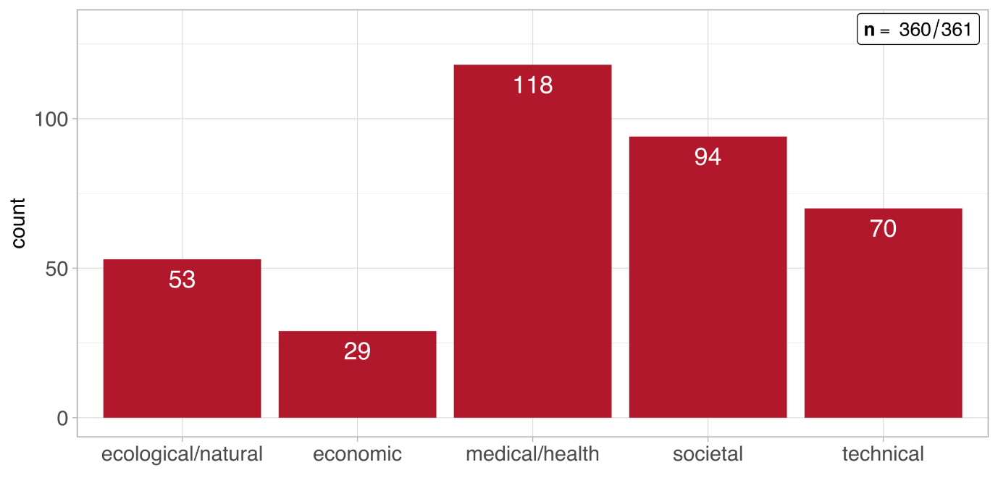

Table 4: Distribution of impulses from the non-academic world (multiple choice)

|  |  |  |
| --- | --- | --- |
| response | abs | % |
| a specific societal problem | 94 | 26.04% |
| a specific economic problem | 29 | 8.03% |
| a specific ecological/natural problem | 53 | 14.68% |
| a specific health/medical problem | 118 | 32.69% |
| a specific technical problem | 70 | 19.39% |
| Other | 62 | 17.17% |

4.3 Extent of trans- and interdisciplinarity in SNSF funded projects

Our proposal aims to trace contributions of research funded by SNSF to social innovations, and to systematise these contributions in a valuation framework. In addition, we aim to identify to what extent contributions to social innovation in SNSF-funded research projects are possible at all, and where further support measures, either provided by SNSF or from outside (e.g. by the universities), could create an added value that could not be tapped so far.

Figure 2**: R&D phases and procedures for social innovation research**



Source: Own illustration based on the stages of SI according to Murray et al. (2010) and the Societal Readiness Levels Concept of the Innovation Fund Denmark.

Our proposal aims to trace contributions of research funded by SNSF to social innovations, and to systematise these contributions in a valuation framework. In addition, we aim to identify to what extent contributions to social innovation in SNSF-funded research projects are possible at all, and where further support measures, either provided by SNSF or from outside (e.g. by the universities), could create an added value that could not be tapped so far.

4.3.1 Inclusion of stakeholders in the pre-project implementation phase

Our proposal aims to trace contributions of research funded by SNSF to social innovations, and to systematise these contributions in a valuation framework. In addition, we aim to identify to what extent contributions to social innovation in SNSF-funded research projects are possible at all, and where further support measures, either provided by SNSF or from outside (e.g. by the universities), could create an added value that could not be tapped so far.

4.3.2 Inclusion of stakeholders in the project implementation phase

Our proposal aims to trace contributions of research funded by SNSF to social innovations, and to systematise these contributions in a valuation framework. In addition, we aim to identify to what extent contributions to social innovation in SNSF-funded research projects are possible at all, and where further support measures, either provided by SNSF or from outside (e.g. by the universities), could create an added value that could not be tapped so far.

### Level and nature of inter-/transdisciplinary involvement

Interdisciplinary cooperation is common among the SNSF funded projects. 41 % of the respondents note that the involvement of academicians from other disciplines was quite central to their specific project (see Figure 1). In total 78 % of the projects were carried out in collaboration with researchers from other disciplines (see Table 1).

*Transdisciplinary involvement* has been measured via categories which indicate the inclusion of different types of societal actors and groups in the research process. Although by far not as central as the interdisciplinary cooperation, different types of transdisciplinary engagement constitute a noteworthy part of the research projects. Transdisciplinary involvement types such as *involvement of citizens*, *involvement of policy makers/public administration*, *involvement of institutions providing welfare or education*, or *involvement of companies*, yield somewhat similar distributions among the projects of the survey respondents (22 % - 27 % of involvement rated above 3; 0 being minimum and 10 the maximum). An exception to this rather equal distribution is media, which was quite often involved in SNSF projects, but rarely centrally. Thus, we assume that media was mainly involved for pure dissemination purposes.

Figure 1: Level of interdisciplinary and transdisciplinary involvement

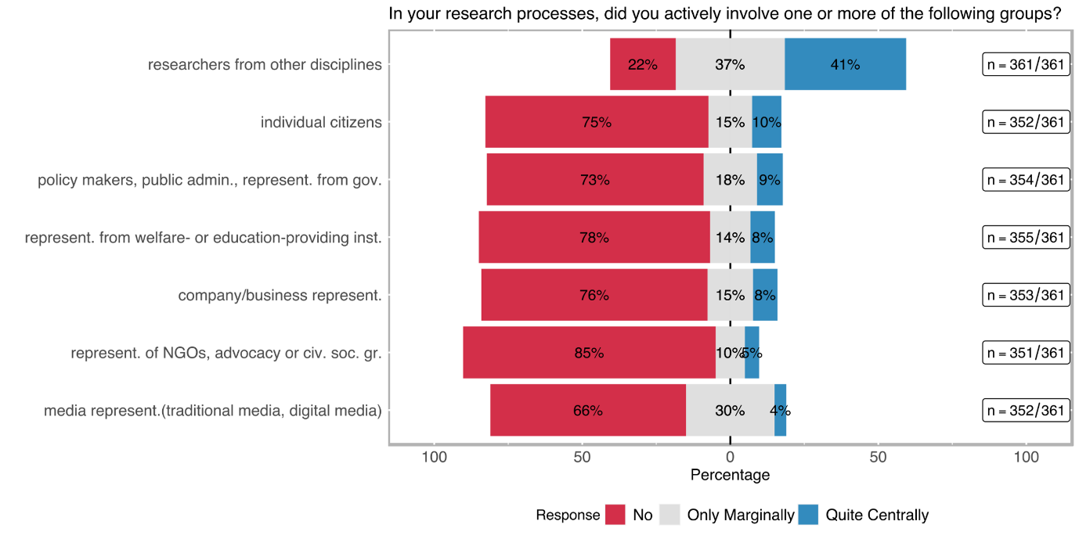

Table 1: Level of interdisciplinary and transdisciplinary involvement

|  |  |  |  |  |  |  |
| --- | --- | --- | --- | --- | --- | --- |
| Involved stakeholder group | no | | only marginally | | quite centrally | |
|  | **abs** | **%** | **abs** | **%** | **abs** | **%** |
| ACADEMIC |  | | | | | |
| researchers from other disciplines (n=361) | 80 | 22.16% | 133 | 36.84% | 148 | 41.00% |
| NON-ACADEMIC |  | | | | | |
| company/business representatives (incl. farmers) (n=352) | 269 | 76.42% | 54 | 15.34% | 29 | 8.24% |
| representatives of NGOs, advocacy or other civil society groups (n=354) | 302 | 85.31% | 35 | 9.89% | 17 | 4.80% |
| policy makers, public administrations, representatives from governmental agencies (n=355) | 260 | 73.24% | 64 | 18.03% | 31 | 8.73% |
| individual citizens (e. g. as beneficiaries, customers, or concerned persons) (n=353) | 266 | 75.35% | 52 | 14.73% | 35 | 9.92% |
| media representatives (traditional media, digital media (e. g. bloggers), journalists, community-led media, etc.) (n=351) | 232 | 66.10% | 105 | 29.91% | 14 | 3.99% |
| representatives from welfare- or education-providing institutions (such as schools, kindergartens, hospitals, or care centres) (n=352) | 275 | 78.13% | 48 | 13.64% | 29 | 8.24% |

To complement the above-mentioned inclusion of stakeholder groups in transdisciplinary research, it might also be interesting to see how many projects chose to work with more than one group, during their implementation. As Figure 2 shows, 37 % of projects did not include any stakeholder groups – in contrast to Figure 1, this means that the share of projects that do not involve any stakeholder groups outside academia is roughly only half as high as the share of a particular stakeholder group to be involved. In fact, the share of projects that include at least one and up to three different stakeholder group amounts to 48 %; 9 % of the surveyed projects include even more than 3 (out of 6) different types of stakeholder groups.

Figure 2: Stakeholder groups involved in transdisciplinary research

Although the centrality of the involvement of stakeholders indicates to which extent specific groups were involved in the project, the role which participating social groups play in transdisciplinary research is often overlooked. Motivated by our literature research, we decided that the *nature of involvement* (indicated with the labels; *consultative, contributory, collaboratively, co-created*) carries at least as much information as the centrality of the involvement about the occurrence of SI-related aspects.

Figure 3 and Table 2 show that *transdisciplinary involvement* is mostly *consultative* or *contributory*. *Collaborative transdisciplinary* involvement is more likely employed when welfare/education institutions or company/business experts are involved in the project (20 % and 22 % respectively). A co-creation approach is rare being followed: the highest co-creative involvement belongs to projects that include individual citizens (10 %).

Figure 3: Nature of transdisciplinary involvement per stakeholder group

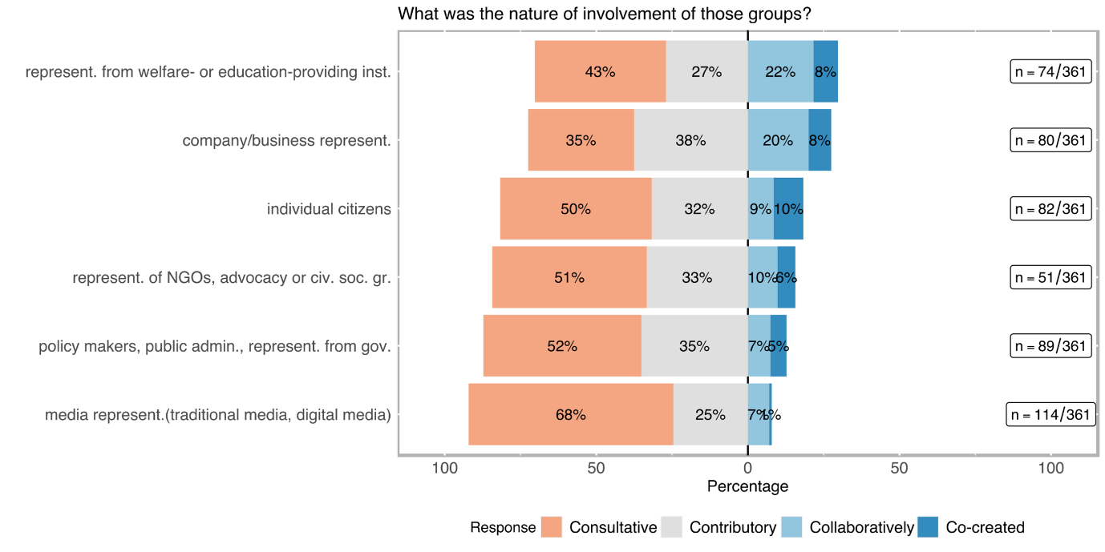

Table 2: Nature of transdisciplinary involvement per stakeholder group

|  |  |  |  |  |  |  |  |  |  |  |
| --- | --- | --- | --- | --- | --- | --- | --- | --- | --- | --- |
| Involved stakeholder group | consultative[4] | | contributory[5] | | | collaborative[6] | | | co-created[7] | |
|  | **abs** | **%** | **abs** | | **%** | **abs** | **%** | | **abs** | **%** |
| ACADEMIC |  | | |  | | | |  | | |
| researchers from other disciplines (n=278) | 37 | 13.31 | 57 | | 20.50 | 109 | 39.21 | | 75 | 26.98 |
| NON-ACADEMIC |  | | |  | | | |  | | |
| company/business representatives (incl. farmers) (n=80) | 28 | 35.00 | 30 | | 37.50 | 16 | 20.00 | | 6 | 7.50 |
| representatives of NGOs, advocacy or other civil society groups (n=51) | 26 | 50.98 | 17 | | 33.33 | 5 | 9.80 | | 3 | 5.88 |
| policy makers, public administrations, representatives from governmental agencies (n=94) | 49 | 52.13 | 33 | | 35.11 | 7 | 7.45 | | 5 | 5.32 |
| individual citizens (e. g. as beneficiaries, customers, or concerned persons) (n=82) | 41 | 50.00 | 26 | | 31.71 | 7 | 8.54 | | 8 | 9.76 |
| media representatives (traditional media, digital media (e. g. bloggers), journalists, community-led media, etc.) (n=114) | 77 | 67.54 | 28 | | 24.56 | 8 | 7.02 | | 1 | 0.88 |
| representatives from welfare- or education-providing institutions (such as schools, kindergartens, hospitals, or care centres) (n=74) | 32 | 43.24 | 20 | | 27.03 | 16 | 21.62 | | 6 | 8.11 |

4.3.2 Inclusion of stakeholders in the project exploitation phase

Our proposal aims to trace contributions of research funded by SNSF to social innovations, and to systematise these contributions in a valuation framework. In addition, we aim to identify to what extent contributions to social innovation in SNSF-funded research projects are possible at all, and where further support measures, either provided by SNSF or from outside (e.g. by the universities), could create an added value that could not be tapped so far.

## Dissemination and Exploitation

### Dissemination Channels

Figure 1: Distribution of dissemination channels

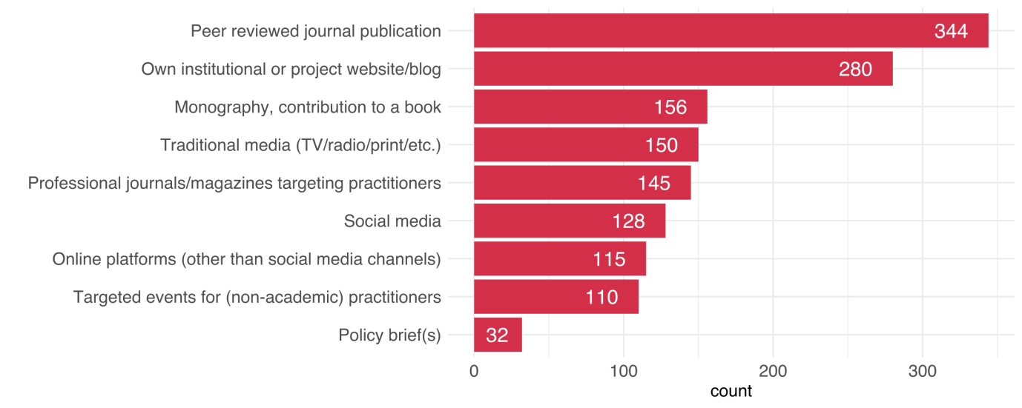

How a project disseminates its results can provide important information about the project’s character and intention. Some of the options like peer-reviewed journal publications or the dissemination on the organisations’ own website have unsurprisingly high numbers (see Figure 1). In general, however, a wide range of dissemination channels was used, including books, traditional and social media, and articles in professional journals for practitioners etc. Policy briefs were rated lowest but 110 projects stated to have organised events for non-academic practitioners (see Table 1).

Table 1: Dissemination channels

|  |  |  |  |  |
| --- | --- | --- | --- | --- |
| Dissemination channel | no | | yes | |
|  | **abs** | **%** | **abs** | **%** |
| Peer reviewed journal publication (n=358) | 14 | 3.91% | 344 | 96.09% |
| Monography, contribution to a book (n=342) | 186 | 54.39% | 156 | 45.61% |
| Conference proceeding (n=356) | 52 | 14.61% | 304 | 85.39% |
| Policy brief(s) (n=333) | 301 | 90.39% | 32 | 9.61% |
| Traditional media (TV/radio/print/etc.) (n=346) | 196 | 56.65% | 150 | 43.35% |
| Professional journals/magazines targeting practitioners (n=343) | 198 | 57.73% | 145 | 42.27% |
| Own institutional or project website/blog (n=354) | 74 | 20.90% | 280 | 79.10% |
| Social media (n=347) | 219 | 63.11% | 128 | 36.89% |
| Online platforms (other than social media and project website/blog; e. g. data or code sharing, citizen science platforms) (n=343) | 228 | 66.47% | 115 | 33.53% |
| (You providing) consultancy (paid or unpaid) (n=342) | 226 | 66.08% | 116 | 33.92% |
| Targeted events for (non-academic) practitioners (n=343) | 233 | 67.93% | 110 | 32.07% |
| General events for a non-academic public (other than practitioners) (n=343) | 207 | 60.35% | 136 | 39.65% |

4.4 Productive interactions: Obstacles and attempted solutions

Our proposal aims to trace contributions of research funded by SNSF to social innovations, and to systematise these contributions in a valuation framework. In addition, we aim to identify to what extent contributions to social innovation in SNSF-funded research projects are possible at all, and where further support measures, either provided by SNSF or from outside (e.g. by the universities), could create an added value that could not be tapped so far.

1. NEW SOCIAL PRACTICES? iNTENDED OUTCOMES, ACTUAL OUTCOMES AND LIMITATIONS

5.1 Social innovation outcome orientation in SNSF projects

Our proposal aims to trace contributions of research funded by SNSF to social innovations, and to systematise these contributions in a valuation framework. In addition, we aim to identify to what extent contributions to social innovation in SNSF-funded research projects are possible at all, and where further support measures, either provided by SNSF or from outside (e.g. by the universities), could create an added value that could not be tapped so far.

### Goals with regard to target groups

Figure 1: Distribution of target group goals

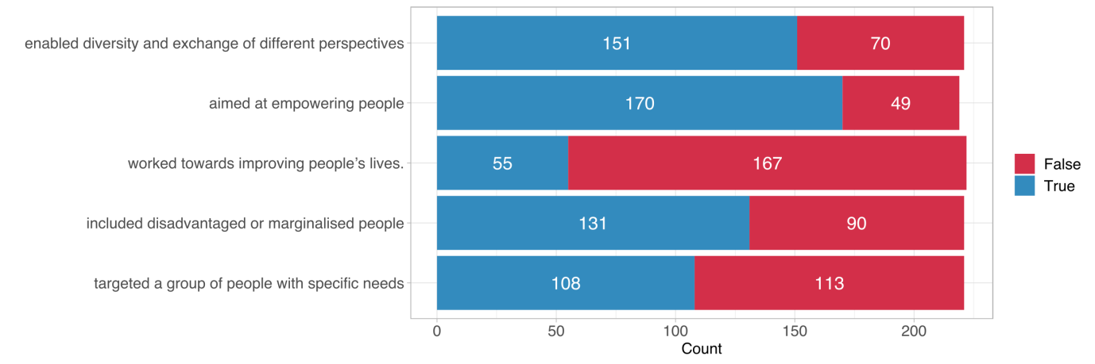

Envisioned social goals of the project can be important indicators of social innovation. Several true/false statements concerning foreseen social impact or social inclusion goals were raised to measure further aspects of transdisciplinarity. *Aim to empower targeted or included social groups* was the most frequently selected category (170 times) followed by *enabling diversity and exchange of different perspectives* (151 times). The category the *project worked towards improving people’s lives* was the least frequent selected category (55 times).

Table 1: Distribution of target group goals

|  |  |  |  |  |
| --- | --- | --- | --- | --- |
| Goal | no |  | yes |  |
|  | **abs** | **%** | **abs** | **%** |
| targeted a group of people with specific social needs (n= 221) | 151 | 68.33% | 70 | 31.67% |
| included socially disadvantaged or marginalised people (n=219) | 170 | 77.63% | 49 | 22.37% |
| worked towards improving people’s lives (n=222) | 55 | 24.77% | 167 | 75.23% |
| aimed at empowering people (in general or specific groups) (n=221) | 131 | 59.28% | 90 | 40.72% |
| enabled diversity and exchange of different perspectives (n=221) | 108 | 48.87% | 113 | 51.13% |

### Intended Effects

In the online survey, we inquired about intended changes to investigate potential project outcomes, both in the long and short term. We differentiated four categories of effects: (i) improving understanding as most generic effect of scientific research; (ii) raising awareness of an issue; (iii) changing attitude, which has a normative change connotation, and (iv) changing behaviour, which has an action-oriented connotation.

*Improving the understanding* as well as *raising awareness* in the general population is by far the most frequently selected category (79 and 50 times respectively; cf. Figure 1 and Table 1). Other arguably stronger types of changes (attitude and behaviour) are occurring relatively less frequent among all of the defined societal actor categories. However, 31 respondents noted that the intended effect (or one of the intended effects) of their research project was a behavioural change among policymakers and/or public administration.

Figure 1: Distribution of intended change

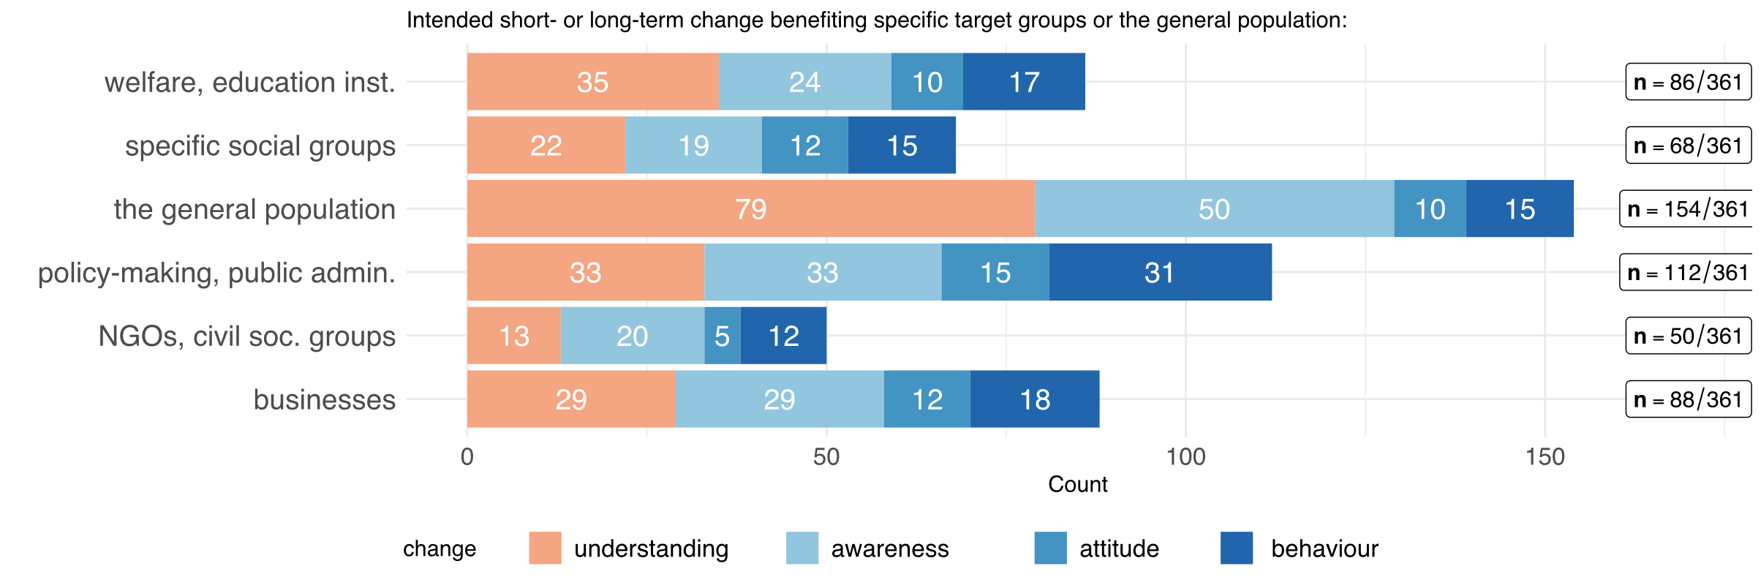

Table 1: Distribution of intended change

|  |  |  |  |  |  |  |  |  |  |  |
| --- | --- | --- | --- | --- | --- | --- | --- | --- | --- | --- |
|  | Changing … | | | | | | | | | |
| Target audience | **under­standing** | | **awareness** | | **attitude** | | **behaviour** | | **other** | |
|  | **abs** | **%** | **abs** | **%** | **abs** | **%** | **abs** | **%** | **abs** | **%** |
| the general population (n=170) | 79 | 46.47% | 50 | 29.41% | 10 | 5.88% | 15 | 8.82% | 16 | 9.41% |
| businesses (n=100) | 29 | 29.00% | 29 | 29.00% | 12 | 12.00% | 18 | 18.00% | 12 | 12.00% |
| specific social groups (n=73) | 22 | 30.14% | 19 | 26.03% | 12 | 16.44% | 15 | 20.55% | 5 | 6.85% |
| welfare- and education-providing institutions (n=93) | 35 | 37.63% | 24 | 25.81% | 10 | 10.75% | 17 | 18.28% | 7 | 7.53% |
| NGOs, advocacy or other civil society groups (n=53) | 13 | 24.53% | 20 | 37.74% | 5 | 9.43% | 12 | 22.64% | 3 | 5.66% |
| policy-making, public administration, governmental agencies (n=117) | 33 | 28.21% | 33 | 28.21% | 15 | 12.82% | 31 | 26.50% | 5 | 4.27% |
| academia (n=312) | 219 | 70.19% | 32 | 10.26% | 21 | 6.73% | 28 | 8.97% | 12 | 3.85% |

5.2 Actual outcomes and limitations

Our proposal aims to trace contributions of research funded by SNSF to social innovations, and to systematise these contributions in a valuation framework. In addition, we aim to identify to what extent contributions to social innovation in SNSF-funded research projects are possible at all, and where further support measures, either provided by SNSF or from outside (e.g. by the universities), could create an added value that could not be tapped so far.

Direct contributions to target group(s)

Research projects funded by SNSF rarely contribute directly to new services, products, or processes. Although the majority of respondents marked 3 or lower on a 0-10 scale for all of the specific categories (see Figure 1), ~ 40 % of the respondents noted that their project results somewhat directly contributed to new/better products and services for the general population. 18 % of respondents even stated to have strongly contributed to benefit the general population (cf. Table 1).

Our definition of SI encompasses outcome-orientation, both tangible and non-tangible. In other words, if the intention to achieve impact is missing, then a constitutive element that characterises social innovation is missing too. This does not mean that the project may not have contributed to social innovation in the end. However, from a definitional point of view, it does not correspond to the intentional understanding of a social innovation.

Figure 1: Direct contribution to target group(s)

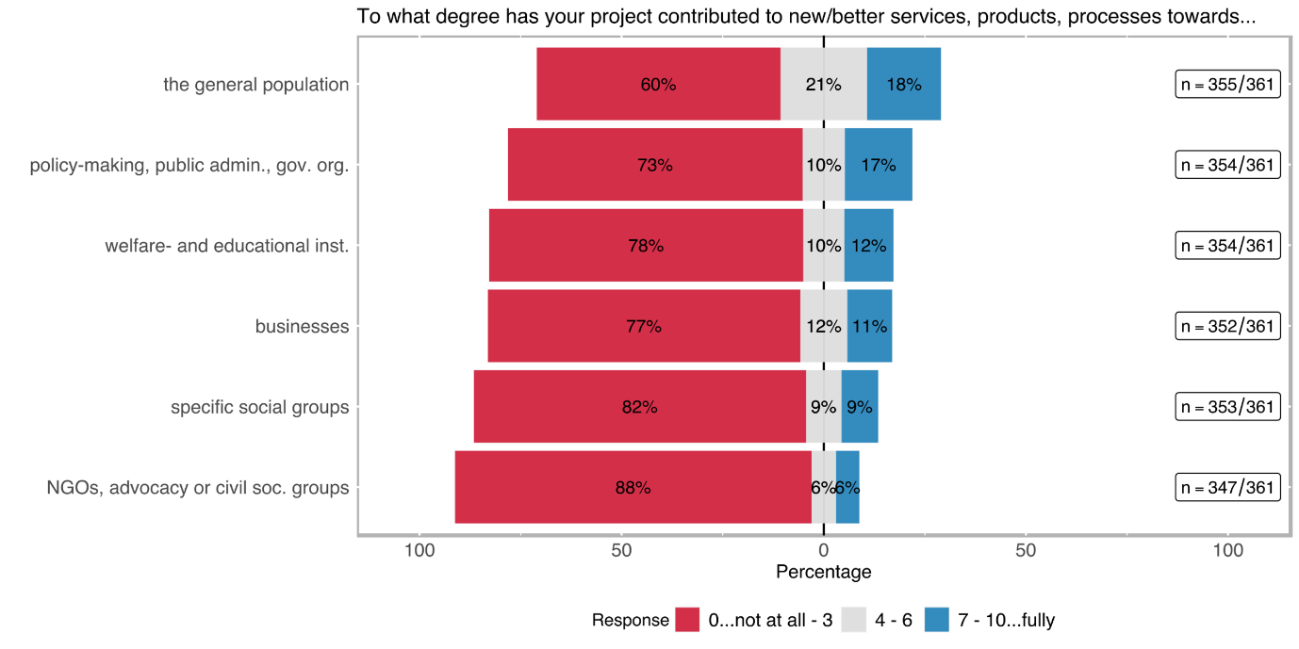

Table 1: Direct contribution to target group(s)

|  |  |  |  |  |  |  |  |  |  |  |  |  |  |  |
| --- | --- | --- | --- | --- | --- | --- | --- | --- | --- | --- | --- | --- | --- | --- |
|  | the general population (n=355) | | busi­nesses (n=352) | | specific social groups[8] (n=353) | | welfare- and education-providing institutions[9] (n=354) | | NGOs, advocacy or other civil society groups (n=347) | | policy-making, public admini­stration, govern­mental agencies (n=354) | | academia (n=357) | |
| re­sponse | **abs** | **%** | **abs** | **%** | **abs** | **%** | **abs** | **%** | **abs** | **%** | **abs** | **%** | **abs** | **%** |
| 0 | 116 | 32.68 | 177 | 50.28 | 223 | 63.17 | 200 | 56.50 | 241 | 69.45 | 185 | 52.26 | 29 | 8.12 |
| 1 | 26 | 7.32 | 32 | 9.09 | 30 | 8.50 | 32 | 9.04 | 27 | 7.78 | 26 | 7.34 | 3 | 0.84 |
| 2 | 39 | 10.99 | 36 | 10.23 | 24 | 6.80 | 21 | 5.93 | 22 | 6.34 | 25 | 7.06 | 8 | 2.24 |
| 3 | 33 | 9.30 | 27 | 7.67 | 13 | 3.68 | 22 | 6.21 | 16 | 4.61 | 22 | 6.21 | 8 | 2.24 |
| 4 | 15 | 4.23 | 13 | 3.69 | 8 | 2.27 | 13 | 3.67 | 7 | 2.02 | 11 | 3.11 | 10 | 2.80 |
| 5 | 40 | 11.27 | 24 | 6.82 | 13 | 3.68 | 12 | 3.39 | 10 | 2.88 | 20 | 5.65 | 27 | 7.56 |
| 6 | 21 | 5.92 | 4 | 1.14 | 10 | 2.83 | 11 | 3.11 | 4 | 1.15 | 6 | 1.69 | 16 | 4.48 |
| 7 | 21 | 5.92 | 9 | 2.56 | 11 | 3.12 | 14 | 3.95 | 9 | 2.59 | 22 | 6.21 | 46 | 12.89 |
| 8 | 22 | 6.20 | 11 | 3.13 | 10 | 2.83 | 14 | 3.95 | 3 | 0.86 | 19 | 5.37 | 59 | 16.53 |
| 9 | 5 | 1.41 | 6 | 1.70 | 4 | 1.13 | 6 | 1.69 | 3 | 0.86 | 5 | 1.41 | 41 | 11.48 |
| 10 | 17 | 4.79 | 13 | 3.69 | 7 | 1.98 | 9 | 2.54 | 5 | 1.44 | 13 | 3.67 | 110 | 30.81 |

### Uptake by decision-makers

The uptake of the project results by decision-makers is one of the indicators of project outcomes. The survey was designed to explore this aspect using two different questions, which were mainly aimed to measure how far the project results have been adopted by the authorities and what was the nature of the uptake.

Figure 3: Uptake of project results by policy-makers

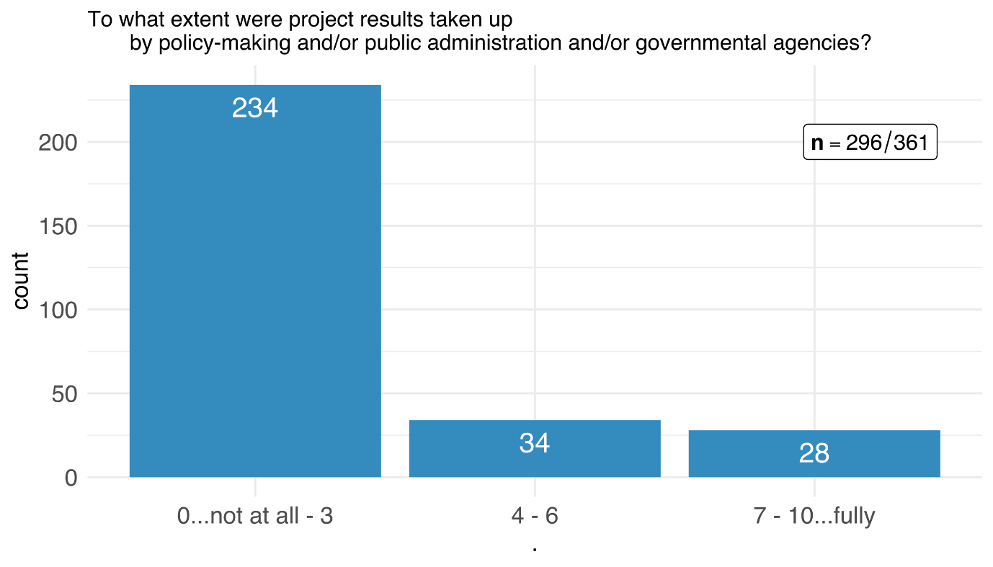

Approximately 20 % of the respondents rated the *uptake of the project results by decision-makers* moderate to high (see Table 3). However, an overwhelming majority of the respondents reported that there was little to no uptake of the project results by policy-makers, public administration, or governmental agencies.

Table 3: Uptake of project results by policy-makers

|  |  |  |
| --- | --- | --- |
|  | adopted by policy (n=296) | |
| response | abs | % |
| 0 | 153 | 51.69% |
| 1 | 22 | 7.43% |
| 2 | 42 | 14.19% |
| 3 | 17 | 5.74% |
| 4 | 9 | 3.04% |
| 5 | 15 | 5.07% |
| 6 | 10 | 3.38% |
| 7 | 9 | 3.04% |
| 8 | 12 | 4.05% |
| 9 | 2 | 0.68% |
| 10 | 5 | 1.69% |
| *not applicable* | *57* |  |
| *no response* | *8* |  |

Figure 4: Kind of uptake of project results by policy-makers

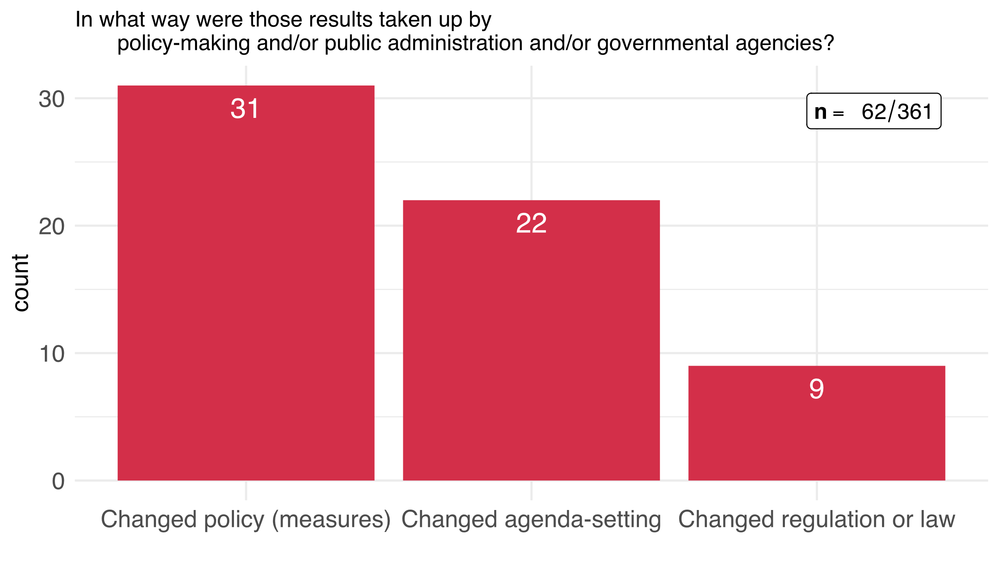

The nature of the policy uptake indicates what kind of a change the uptake by policymakers and public administration caused. Nine respondents claim that the results of their projects changed/influenced laws and regulations, 22 respondents note that the results changed specific agenda-settings and 31 reported about changed policies (i. e. changes in policy measures) (see Figure 4). This means that 17 % of the SNSF funded projects had an impact on policy or public administration, mostly in the way how policies or policy measures are designed and implemented.

Table 4: Kind of uptake of project results by policy-makers

|  |  |  |
| --- | --- | --- |
|  | Nature of uptake by policy-makers (n=62) | |
| response | **abs** | **%** |
| Changed policy (measures) | 31 | 34.83% |
| Changed agenda-setting | 22 | 24.72% |
| Changed regulation or law | 9 | 10.11% |
| *Other* | *27* |  |

### Impact statements

Figure 5: Impact statements – change affected through the funded research project

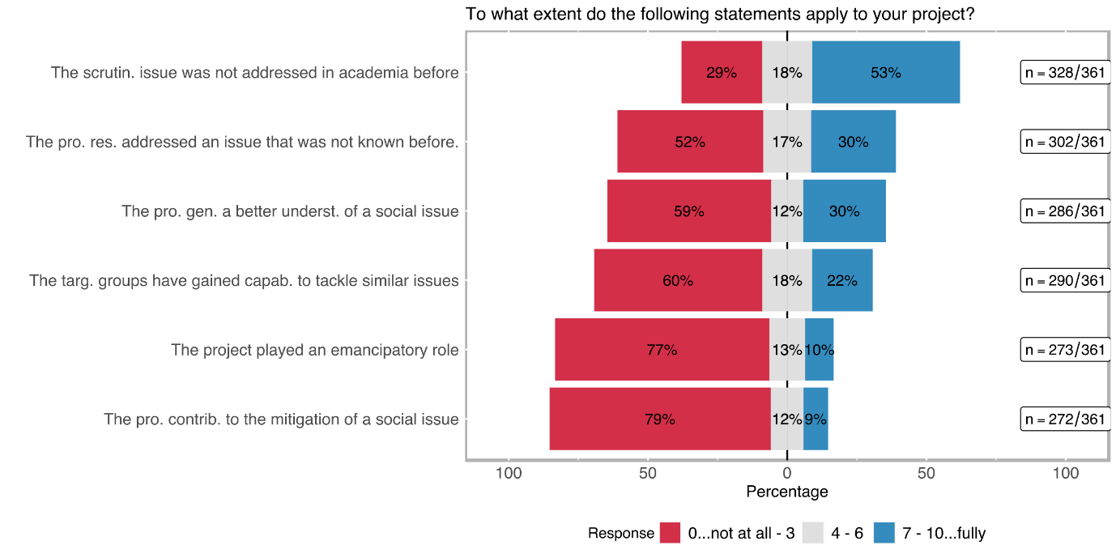

The last question in the outcome orientation section of the survey focused on impact statements and how the impacts of the scrutinised SNSF-funded projects corresponded to these statements. The statements are chosen to address SI-relevant aspects directly.

The academic dimension was by far the highest-rated statement among the survey respondents (see Figure 5), 53 % of the respondents rated the statement *the scrutinised issue was not (widely) addressed in academia before* 7 or higher on a scale from 0 to 10 (cf. Table 5).

This result is followed by a similar statement *the project results addressed an issue that was not (widely) known before* which was specifically directed to the novelty of the issue for the public, 30 % of the respondents rated this statement 7 or higher.

The statement that *the project generated a deeper/better understanding of the social issue* was rated similarly by the respondents. It is striking that as many as 10 % and 9 %, respectively, of the SNSF-funded projects contributed to an *emancipatory impact* or the *mitigation of a social issue*.

Table 5: Impact statements – change affected through the funded research project

|  |  |  |  |  |  |  |  |  |  |  |  |  |
| --- | --- | --- | --- | --- | --- | --- | --- | --- | --- | --- | --- | --- |
|  | capacity to tackle similar issues (n=290) | | Emancipa­tion (n=273) | | deeper/ better understan­ding of a specific social issue (n=286) | | mitigation of a social issue (n=272) | | issue not (widely) known in the society (n=302) | | issue not (widely) addressed in academia (n=328) | |
| response | **abs** | **%** | **abs** | **%** | **abs** | **%** | **abs** | **%** | **abs** | **%** | **abs** | **%** |
| 0 | 105 | 36.21 | 142 | 52.01 | 117 | 40.91 | 155 | 56.99 | 102 | 33.77 | 62 | 18.90 |
| 1 | 22 | 7.59 | 22 | 8.06 | 22 | 7.69 | 28 | 10.29 | 17 | 5.63 | 10 | 3.05 |
| 2 | 26 | 8.97 | 26 | 9.52 | 10 | 3.50 | 17 | 6.25 | 13 | 4.30 | 8 | 2.44 |
| 3 | 22 | 7.5% | 20 | 7.33 | 19 | 6.64 | 16 | 5.88 | 26 | 8.61 | 15 | 4.57 |
| 4 | 18 | 6.21 | 11 | 4.03 | 12 | 4.20 | 8 | 2.94 | 17 | 5.63 | 16 | 4.88 |
| 5 | 19 | 6.55 | 15 | 5.49 | 9 | 3.15 | 16 | 5.88 | 19 | 6.29 | 25 | 7.62 |
| 6 | 15 | 5.17 | 9 | 3.30 | 12 | 4.20 | 8 | 2.94 | 16 | 5.30 | 18 | 5.49 |
| 7 | 24 | 8.28 | 10 | 3.66 | 25 | 8.74 | 6 | 2.21 | 23 | 7.62 | 39 | 11.89 |
| 8 | 18 | 6.21 | 6 | 2.20 | 23 | 8.04 | 9 | 3.31 | 24 | 7.95 | 54 | 16.46 |
| 9 | 9 | 3.10 | 6 | 2.20 | 17 | 5.94 | 4 | 1.47 | 15 | 4.97 | 27 | 8.23 |
| 10 | 12 | 4.14 | 6 | 2.20 | 20 | 6.99 | 5 | 1.84 | 30 | 9.93 | 54 | 16.46 |
|  |  |  |  |  |  |  |  |  |  |  |  |  |

### Scalability

Figure 2: Types of scalability

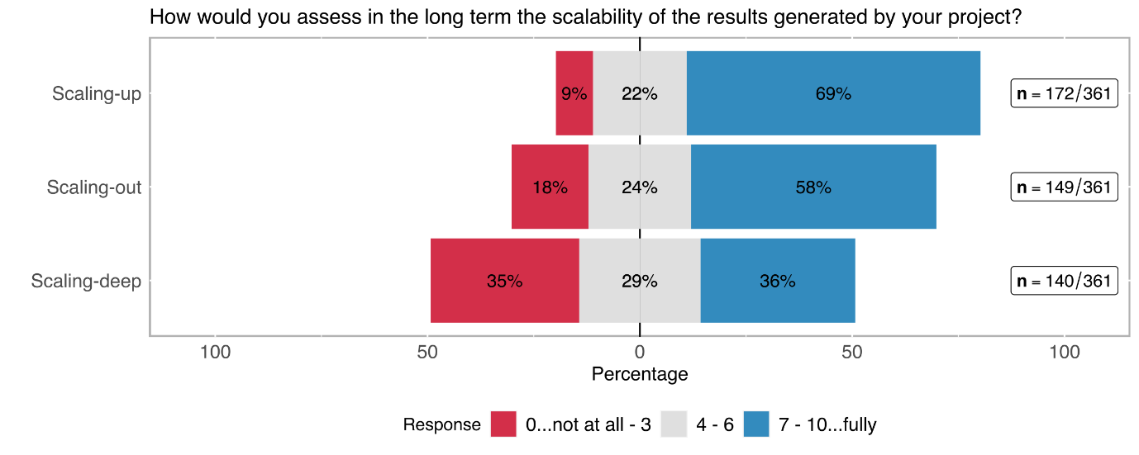

The scalability of the generated solutions to be applied in different contexts is another important goal in SI. 69 % of the respondents noted that the solutions generated throughout the project potentially have a high capability to be scaled up (cf. Figure 2 and Table 2), i. e. to achieve a higher impact if further used. The potential for scaling-out to different geographic areas was highly rated as well. This is hardly surprising, because most scientific research is not regionally limited but strives for universal knowledge and insights. Interestingly, 36 % of the respondents also think that their project results can potentially have a transformative impact in the sense of changing cultural and social values (scaling-deep).

Table 2: Types of scalability

|  |  |  |  |  |  |  |
| --- | --- | --- | --- | --- | --- | --- |
|  | Scaling-up (to achieve a higher impact) (n=172) | | Scaling-out (to different geographic areas) (n=149) | | Scaling-deep (by changing cultural and social values and practices) (n=140) | |
| response | abs | % | abs | % | abs | % |
| 0 | 3 | 1.74% | 11 | 7.38% | 17 | 12.14% |
| 1 | 4 | 2.33% | 6 | 4.03% | 12 | 8.57% |
| 2 | 2 | 1.16% | 7 | 4.70% | 10 | 7.14% |
| 3 | 6 | 3.49% | 3 | 2.01% | 10 | 7.14% |
| 4 | 6 | 3.49% | 5 | 3.36% | 13 | 9.29% |
| 5 | 21 | 12.21% | 25 | 16.78% | 17 | 12.14% |
| 6 | 11 | 6.40% | 6 | 4.03% | 10 | 7.14% |
| 7 | 36 | 20.93% | 24 | 16.11% | 16 | 11.43% |
| 8 | 38 | 22.09% | 33 | 22.15% | 15 | 10.71% |
| 9 | 10 | 5.81% | 5 | 3.36% | 5 | 3.57% |
| 10 | 35 | 20.35% | 24 | 16.11% | 15 | 10.71% |

1. the last miles – what does it take?

Our proposal aims to trace contributions of research funded by SNSF to social innovations, and to systematise these contributions in a valuation framework. In addition, we aim to identify to what extent contributions to social innovation in SNSF-funded research projects are possible at all, and where further support measures, either provided by SNSF or from outside (e.g. by the universities), could create an added value that could not be tapped so far.

1. WRAP-UP 1: VALUATION of social innovation as potential outcome category of SNSF funded research

Our proposal aims to trace contributions of research funded by SNSF to social innovations, and to systematise these contributions in a valuation framework. In addition, we aim to identify to what extent contributions to social innovation in SNSF-funded research projects are possible at all, and where further support measures, either provided by SNSF or from outside (e.g. by the universities), could create an added value that could not be tapped so far.

1. WRAP-UP 2: TOWARDS A MODEL OF ASSESSING snsf’ CONTRIBUTION TO SOCIAL INNOVATIONS

Our proposal aims to trace contributions of research funded by SNSF to social innovations, and to systematise these contributions in a valuation framework. In addition, we aim to identify to what extent contributions to social innovation in SNSF-funded research projects are possible at all, and where further support measures, either provided by SNSF or from outside (e.g. by the universities), could create an added value that could not be tapped so far.

1. LITERATURE

Antons, D., Grünwald, E., Cichy, P. and Salge, T.O. (2020), ‘The application of text mining methods in innovation research: current state, evolution patterns, and development priorities’, in R&D Management, 50: 329-351. https://doi.org/10.1111/radm.12408

Benneworth, P. (2015), ‘Tracing How Arts and Humanities Research Translates, Circulates and Consolidates in Society. How have Scholars been Reacting to Diverse Impact and Public Value Agendas?’, *Arts and Humanities in Higher Education,* 14 (1), 45-60.

Blei, D. M., Ng, A. Y., & Jordan, M. I. (2003), ‘Latent dirichlet allocation’, in Journal of machine Learning research, 3(Jan), 993-1022

Bonno, Pel et al. (2020), ‘Towards a theory of transformative social innovation -- A relational framework and 12 propositions’, in Research Policy 49.8 (2020): 104080

Bornstein, N, Pabst, S and Sigrist, S. (2014), Zur Bedeutung von sozialer Innovation in Wissenschaft und Praxis. W.I.R.E, Forschungsbericht erstellt im Auftrag des Schweizerischen Nationalfonds (SNF).

Brundenius, C. (2017), ‘Challenges of rising inequalities and the quest for inclusive and sustainable development’, in C. Brundenius, B. Göransson, and J. M. Carvalho de Mello, (eds*) ‘Universities, Inclusive Development and Social Innovation’*, Switzerland: Springer, 9 -69.

Cana, Umit and Bilal Alatas (2020), ‘A new direction in social networkanalysis: Online social network analysis problems and applications’, In Physica A: Statistical Mechanics and its Applications 535: 122372, doi: 10.1016/j.physa.2019.122372

Cunha, J. and Benneworth, P. (2013), ‘Universities’ contributions to social innovation: towards a theoretical framework’, paper presented at EURA Conference 2013, 3-6 July, Enschede, The Netherlands.

Davidovitch, N., and Eckhaus, E. (2018), ‘Effect of faculty on research cooperation and publication: Employing natural language processing’, in *Economics & Sociology* 11.4 (2018): 173

Dees, J. G. (1998), ‘The Meaning of Social Entrepreneurship’, Graduate School of Business. Stanford University.

Degelsegger, A. and Kesselring, A. (2012), ‘Do Non-Humans Make a Difference? The Actor-Network-Theory and the Social Innovation Paradigm’, in H. W. Franz, J. Hochgerner and J. Howaldt (eds), *‘Challenge social innovation Potentials for business, social entrepreneurship, welfare and civil society’*, Berlin and New York: Springer, 57-72.

Ferner, Cornelia, et al. (2020) ‘Automated Seeded Latent Dirichlet Allocation for Social Media Based Event Detection and Mapping`, in Information 11.8 (2020): 376.

Godin, B. (2012), ‘Social Innovation: Utopias of Innovation from c.1830 to the Present’, project on the Intellectual History of Innovation, Working Paper N. 11. Montreal.

Gök, A., Milosevic, N., Nenadic, G., Catalano, G., Daraio, C., Gregori, M., Moed, H. F. and Ruocco, G, eds. (2019) Using machine learning and text mining to classify fuzzy social science phenomenon : the case of social innovation. In: 17th International Conference on Scientometrics and Informetrics, ISSI 2019. International Society for Scientometrics and Informetrics, ITA, pp. 2171-2176. ISBN 9788833811185

Hellsten, I., Opthof, T. and Leydesdorff, L. (2020): N-mode network approach for socio-semantic analysis of scientific publications. Poetics, Volume 78. <https://doi.org/10.1016/j.poetic.2019.101427>

Howaldt, J. (2019), ‘New pathways to social change – creating impact through social innovation research’, *fteval Journal for Research and Technology Policy Evaluation,* 48/July 2019, 37-48.

Howaldt, J., Kopp, R. and Schwarz, M. (2015), *‘On the theory of social innovations: Tarde's neglected contribution to the development of a sociological innovation theory’*, Weinheim: Beltz Juventa. <https://nbn-resolving.org/urn:nbn:de:0168-ssoar-419633>

Howaldt, J., Butzin, A., Domanski, D. and Kaletka, C. (2014), ‘Theoretical Approaches to: Social Innovation. A Critical Literature Review’, a deliverable of the project ‘Social Innovation: Driving Force of Social Change’ (SI-DRIVE), Dortmund: Sozialforschungsstelle.

Howaldt, J. and Schwarz, M. (2010), ‚Social Innovation: Concepts, Research Fields and International Trends’, IMO International Monitoring. Dortmund: Sozialforschungsstelle, TU Dortmund University.

Li, X., Ouyang, J., Zhou, X., Lu, Y., and Liu, Y. (2015), Supervised labeled latent Dirichlet allocation for document categorization. *Applied Intelligence*, *42*(3), 581-593.

Lindstedt, N. C. (2019), Structural Topic Modeling For Social Scientists: A Brief Case Study with Social Movement Studies Literature, 2005–2017. *Social Currents*, *6*(4), 307–318. <https://doi.org/10.1177/2329496519846505>

Lizuka, M. (2013), ‘Innovation systems framework: still useful in the new global context?’, UNU-MERIT Working Papers #2013-005.

Moulaert, F., Mac Callum, D. and Hillier, J. (2013), ‘Social Innovation: intuition, precept, concept, theory and practice’, in F. Moulaert, D. MacCallum, A. Mehmood, and A. Hamdouch, (eds), *The International Handbook on Social Innovation: Collective Action, Social Learning and Transdisciplinary Research*, Cheltenham: Edward Elgar, pp. 13-24.

Murray, R., Caulier-Grice, J and Mulgan, G. (2010), ‘The Open Book of Social Innovation’, NESTA and the Young Foundation.

Novotny, H., König, T. and Schuch, K. (2019), ‚Impact Re-Loaded’, *fteval Journal for Research and Technology Policy Evaluation,* 48/July 2019, 8-9.

Nussbaum, M. (2010), *Not for Profit. Why Democracy Needs the Humanities.* Princeton: Princeton University Press.

Perotte, A. J., Wood, F., Elhadad, N., and Bartlett, N. (2011), Hierarchically supervised latent Dirichlet allocation. In *Advances in neural information processing systems* (pp. 2609-2617).

Pol, E and Ville, S. (2008), ‘Social Innovation: Buzz Word Or Enduring Term? Working Paper 08-09, Wollongong: Department of Economics, University of Wollongong.

Prüfer, P. and Rexroth, M. (2005), Kognitive Interviews. ZUMA-How-to-Reihe Nr. 15.  
<https://www.gesis.org/fileadmin/upload/forschung/publikationen/ge-sis_reihen/howto/How_to15PP_MR.pdf>

Ramage, D., Rosen, E., Chuang, J., Manning, C. and Mcfarland, D. (2009). Topic Modelling for the Social Sciences.

Reale, E., Avramov, D., Canhial, K., Donovan, C., Flecha, R., Holm, P., Larkin, C., Lepori, B., Mosoni-Fried, J., Oliver, E., Primeri, E., Puigvert, L., Scharnhorst, A., Schubert, A., Soler, M., Soòs, S., Sordé, T., Travis, C. and Van Horik, R. (2018), ‘A review of literature on evaluating the scientific, social and political impact of social sciences and humanities research, *Research Evaluation,* 27 (4), 298–308.

Roberts E. M., Brandon M. S. and Edoardo M. A. (2016), A Model of Text for Experimentation in the Social Sciences, *Journal of the American Statistical Association*, 111:515, 988-1003, DOI: 10.1080/01621459.2016.1141684

Schäfer, T. and Kieslinger, B. (2016), *‘Supporting emerging forms of citizen science: A plea for diversity, creativity and social innovation’*, Journal of Science Communication, 15(2), 1-12.

Schuch, K. (2019), ‘The contribution of social sciences and humanities to social innovation’, in J. Howaldt, A. Schröder, C. Kaletka, and M. Zirngiebl, M. (eds.), *Atlas of Social Innovation*, *2nd Volume: A World of New Practices’*, Munich: Oekom Verlag, 95-98.

Schuch, K. and Salamon, N. (2021), ‘Reflections on the presumably difficult relation between social innovation and social sciences‘, in J. Howaldt, C. Kaletka and A. Schröder (eds), A Research Agenda for Social Innovation, Edward Elger Publishing (forthcoming).

Shirk, J. L. et al. (2012). Public participation in scientific research: a framework for deliberate design. Ecology and Society 17(2). Spaapen and Drooge, 2011

Smith, Steven T., Edward K. Kao, Danelle C. Shah, Olga Simek, and Donald B. Rubin (2018), ‘Influence Estimation on Social Media Networks Using Causal Inference’, in IEEE Statistical Signal Processing Workshop (SSP), doi: 10.1109/SSP.2018.8450823

Stanley Wasserman and Katherine Faust (1994), ‘Social Network Analysis: Methods and Applications’, Vol. 8. Cambridge university press.

Wen, Sheng et al. (2015), ‘A Sword with Two Edges: Propagation Studies on Both Positive and Negative Information in Online Social Networks’, in IEEE Transactions on Computers, vol. 64, no. 3, pp. 640-653, doi: 10.1109/TC.2013.2295802

1. ANNEX



**Getting in touch with the ZSI – Zentrum für Soziale Innovation**

Address:

Linke Wienzeile 246

1150 Vienna

Austria

Phone:

0043-1-4950442-0

eMail:

[*office@zsi.at*](mailto:office@zsi.at)

www.zsi.at

1. cf. *What is transdisciplinary research?* at <https://naturalsciences.ch/transdisciplinarity> [last accessed: March 2022]
2. To reduce the overall time needed to fill in the online questionnaire, filters based on responses to previous questions were used. This is an example of such a filter – only those participants would actually get to self-assess their project’s contribution to SI who were at least moderately familiar with the concept of SI (5 or higher).
3. An index based on a statistical model, both of which will be presented as part of the final report.
4. provide information via interviews, online questionnaires, etc.
5. consultative + contributing through collecting data, validating data, disseminating results, etc.
6. contributory + interpreting data and/or drawing conclusions
7. collaborative + participated in designing study and/or determining objectives
8. e. g. women/men/non-binary, youth/elderly; migrants; or minorities/indigenous people
9. such as schools, kindergartens, hospitals, or care centres